Section G — Comprehension Cloze  
Fill in each blank with a suitable word.

(15 marks)

The next time you eat a bar of chocolate, you may not have to feel so guilty about

it anymore. Although if is known for _________ __________weight gain, it has some  
(51)  
surprisingly gcod health benefits too. Chocolate is made from the seeds of the tropical

cacao tree. In the 1400s, chocolate became very _________. _____ in many countries  
(52)  
and its demand exploded. Chocolate _________ ___(EMPTy) since become a food product  
(53) x  
that millions of people enjoy every day due to its unique and sweet taste. However, what

___________ does eating chocolate nave on our health’?  
(54)  
Chocolate is thought to be bad for health because of its high fat and sugar

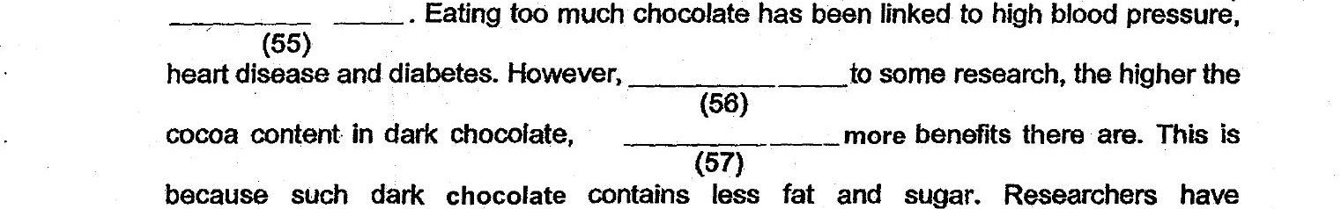

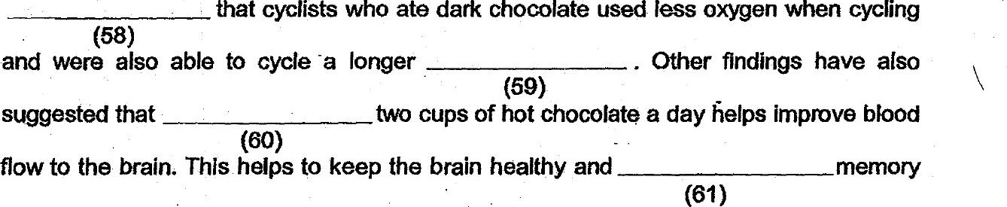

loss In older peopie.

However, milk ‘chocolate manufacturers claim that their product is  
  
_________ ss for health than dark chocolate because it _________ ___———__—sprotein  
(62) (63)  
  
and calcium. As of now, more research is needed to confirm if eating any kind of chocolate

can _________ __ _________ improve people's health since chocolate does not only have  
(64)  
cocoa _________ _ (FMP Ty) also other ingredients. The benefits and risks of these other  
(65)  
ingredients, such as sugar and fat, need to be considered as well.

Adapted trom htips:/7 q inewstoday.com  
Score: